Week 10. Elevator Two (freight elevator with lights and door)
Our elevator so far is pretty dangerous, no door!, and not very user friendly. Let’s add a door and lights for every button so that the rider knows that the computer received her button press. Make a copy of your Elevator One project and call it Elevator Two, and make its circuit look like this - including ALL annotations.
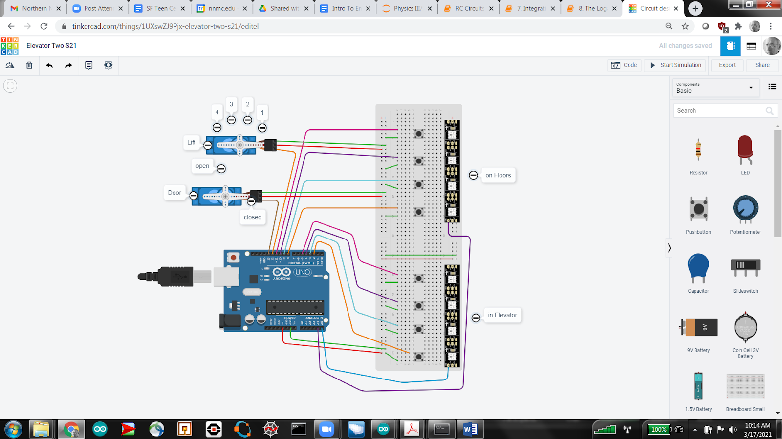
Retaining last week’s logic, when a button is pressed
- its light should go on,
- the Lift should move to the desired floor,
- the door should open,
- the light should go off,
- the Door should close
Your finished project should perform as in this video.
You see that we are adding hardware and actions to last week’s project. You know how to add a door servo (I would call it Door). To properly place your lightstrips please pay very careful attention to the direction of the arrow - and then align their 5V and GND terminals with your plus and minus right-side rails (that are fed from jumpers from your left-side rails).
The new part is then adding and coding our two light strips. These are super powerful, super exciting devices. There is a great library of functions that make these lights easy to control.
Let’s see what is necessary to use these tools to control the lights in the elevator. The preamble and setup code is very much like what we needed to use the LCD.
In the preamble ( include helper library and name (Elights) a light strip and specify its number of lights (4) and its control pin (A5) )
#include <Adafruit_NeoPixel.h>
Adafruit_NeoPixel Elights = Adafruit_NeoPixel(4, A5, NEO_GRB + NEO_KHZ800);

In the setup() routine ( just start up your named light strip )
Elights.begin();
In the loop() routine we can send a particular color to a particular place (pixel, RGB LED). Our 4 pixels are numbered 0, 1, 2, 3 - in the direction of the arrow on the light strip, with 0 at the base and 3 at the tip. We specify a color via a triple (R, G, B) of Red, Green, and Blue, and intensities, each between 0 and 255. For example,
Elights.setPixelColor(2, Elights.Color(0, 0, 255));
Elights.show();

will turn the 3rd pixel blue, and
Elights.setPixelColor(2, Elights.Color(0, 0, 0));
Elights.show();

will turn the 3rd pixel off.
You now have all of the tools you need to complete this project. Be sure to experiment with delays after writing to a servo to give the elevator a chance to get to its floor before it opens its door - and leave the door open long enough for folks to get in and out and press the elevator button.

